**Simulation-4**

**Aim: Application of MATLAB for the design of Buck-Boost Chopper.**

**Software Required**

* MATLAB SIMULINK

**Theory:**

**What is a Chopper?**

A chopper converts a fixed D.C voltage voltage to a variable D.C voltage. Hence, these are also known as DC to DC converters. In order to turn offf the thyristor in chopper circuits forced commutation or load commutation is required as it does not undergo natural communation.The Applications of Choppers are: used in dc drives, subway cars, trolley buses, battery driven vehicles etc.

**What is a Buck-Boost Chopper?**

A Buck-Boost chopper is a DC-DC converter. A simple buck converter can only produce voltages lower than the input voltage, and a boost converter, only voltages higher than the input. Therefore, this converter can operate as a buck or a boost converter depending on the needs of the output voltage.

**Working of a Buck-Boost Chopper:**

A buck-boost converter (dc-dc) is shown in the Fig below. Only a switch is shown, for which a device belonging to transistor family is generally used. Also, a diode is used in series with the load. The connection of the diode may be noted. The inductor, L is connected in parallel after the switch and before the diode. A capacitor, C is connected in parallel with the load. The polarity of the output voltage is opposite to that of input voltage here.

When the switch, S is put ON, the supply current flows through the path, Vs, S and L, during the time interval, Ton. The currents through both source and inductor (iL) increase and are same, with d iL/dt positive. The polarity of the induced voltage is same as that of the input voltage.

Then, the switch, S is put OFF. The inductor current tends to decrease, with the polarity of the induced emf reversing. *( diL/dt )* is negative now, the polarity of the output voltage, *Vo* being opposite to that of the input

voltage, *Vs*. The path of the current is through L, parallel combination of load & C, and diode D, during the time interval, *Toff*. The output voltage remains nearly constant, as the capacitor is connected across the load.

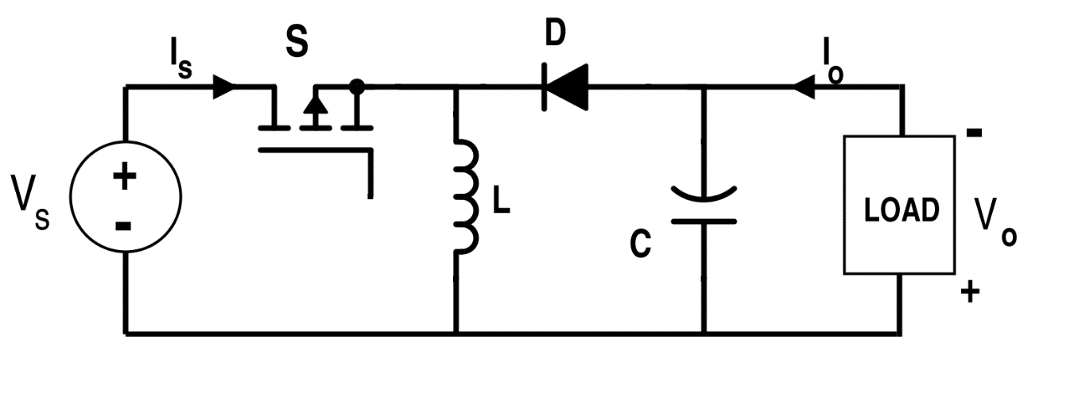

*Fig 1: Circuit of a Buck-Boost converter*

**Waveforms:**

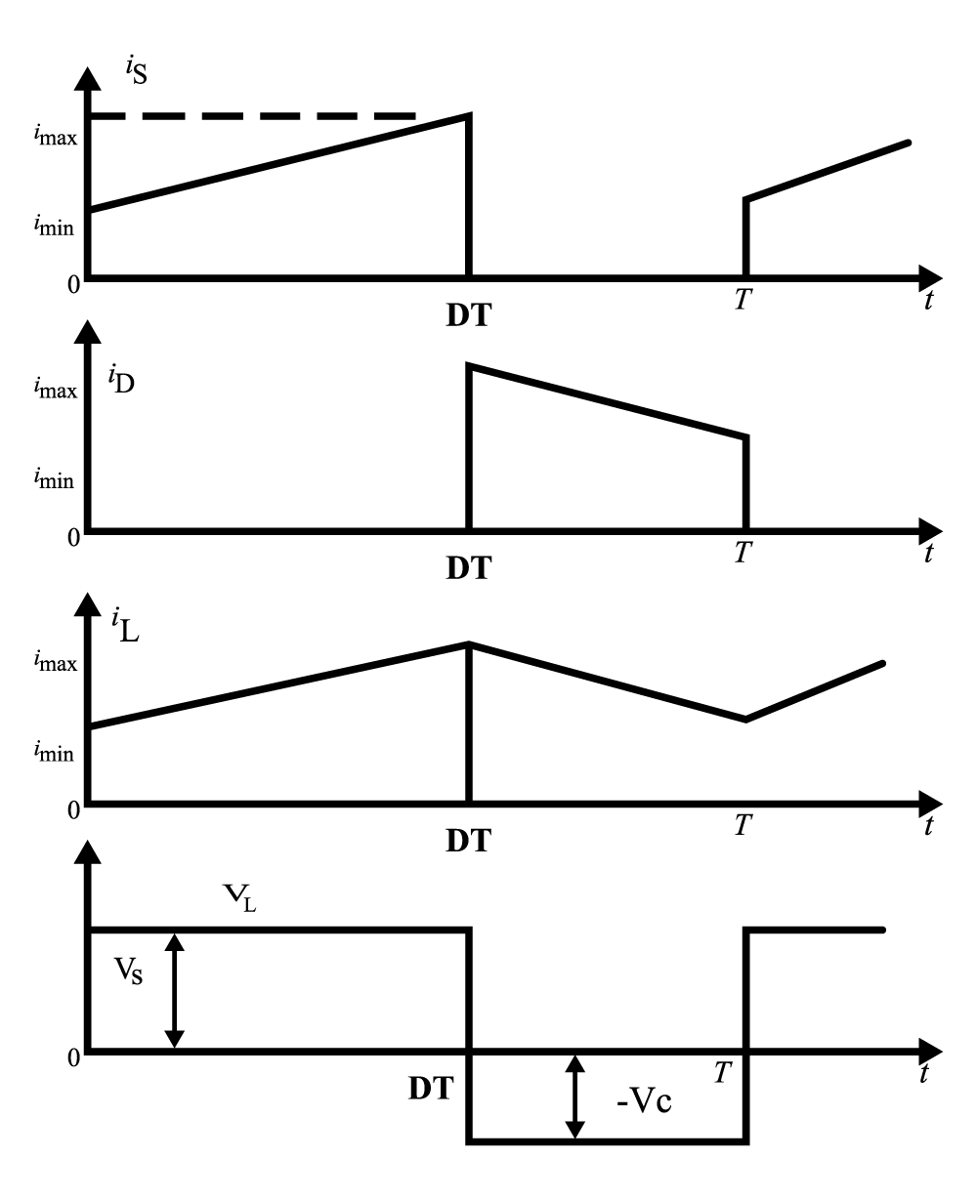

*Fig 2: Waveforms of Buck-Boost chopper*

**Procedure:**

* Firstly, MATLAB Simulink interface should be opened.
* Once, the Simulink is opened, one should open the power libraries in MATLAB.
* Once, the libraries are opened, a MOSFET, DC voltage source, Capacitor, Inductor, Resistor, diode, Bus selector, Voltage measurement, mean value, Display, Pulse generator, Multi-meter, Mux, scope and Power Gui are chosen for designing a Buck-Boost converter.
* The parameters of the above components are set to the needs of this simulation.
* All the above components are connected accordingly.
* After the connections are done, the circuit is simulated, after which 38.8 is displayed. For the output of the buck-boost converter, scope should be pressed. The scope is connected with the pulse generator, MOSFET current, MOSFET voltage, Diode current, Inductor current and Inductor voltage.
* The output waveforms are obtained through the Scope.

**Circuit Simulated in MATLAB**



*Fig 3: Buck-Boost converter in Matlab Simulink*

**Output Waveforms obtained:**

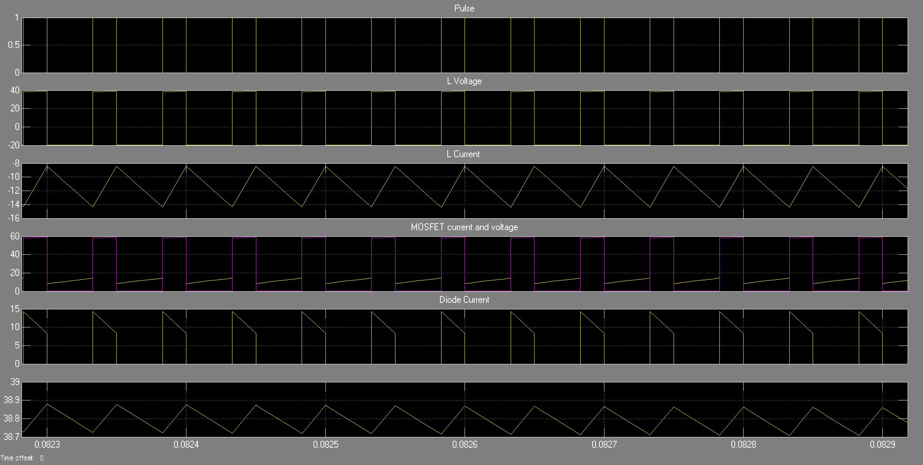

*Fig 4: Output waveforms of Buck-Boost converter*

**Result:**

The output of Buck-Boost converter has been obtained in MATLAB Simulink and the result has been verified.